Water Quality Analysis

NM- Phase 2 Project

NM –id: au712521104030

# Project Overview

In this project, we will create a comprehensive water quality analysis system that combines environmental sensors, data collection, and analysis to monitor the quality of water in natural bodies of water, such as rivers, lakes, and streams. This project aims to support environmental conservation efforts by providing real-time data on water quality, allowing for early detection of pollution events, and enabling data-driven decision-making.

# Project Components

## Sensor Network Setup

02

01

Deploy a network of water quality sensors at various key locations within the target water body.

## Data Repository and Visualization

04

03

Set up a cloud-based database to store the incoming sensor data.

## Data Transmission

Utilize wireless communication (e.g., LoRa, Wi-Fi, or GSM) to transmit real-time data from the sensors to a central data repository.

## Alerting System

Implement an alerting system that triggers notifications (email or SMS) when water quality parameters exceed predefined thresholds, indicating potential environmental issues.

|  |
| --- |
| Project Components |

## Historical Data Analysis

06

Develop data analysis algorithms using Python or R to identify patterns, anomalies, and trends in historical water quality data.

## GIS Mapping

08

Create a geographical information system (GIS) interface to map sensor locations and overlay water quality data.

07

05

## Data Integration

Integrate external data sources, such as weather data or pollution reports, to contextualize water quality data.

## User Access Control

Implement user authentication and authorization to control access to the data and dashboard.

# Quality Solution

Water quality analyzers are used for monitoring process chemistry including water quality, providing process optimization and control. Water quality parameters are of three types – physical,

chemical and biological

–

and are tested or

monitored according to the desired water

parameters.

# Project Benefits

## Environmental ConservationResearch and Monitoring

The project assists in the early detection Researchers can use the historical of pollution events and ensures timely data for in-depth environmental response to protect aquatic ecosystems. studies and monitoring trends. **Public Awareness**

The project's data can be made accessible to the public, raising awareness of water quality and environmental issues.

Water quality parameters include chemical, physical, and biological properties and can be tested or monitored based on the desired water parameters of concern.

Water quality analysis is a complex process that involves a series of steps to assess the physical, chemical, and biological characteristics of water. These analyses are crucial for ensuring safe drinking water, monitoring environmental quality, and managing water resources. Here are

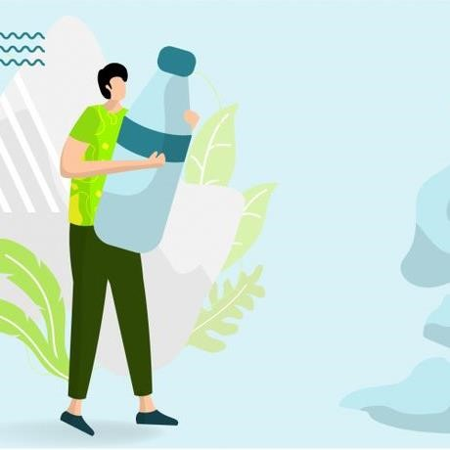

the steps involved in a comprehensive

water quality analysis.

**The steps involved in a comprehensive water quality analysis.**

## 01 Sampling

This involves selecting appropriate sampling locations, depths, and times. Samples should be collected in clean, sterile containers to avoid contamination.

## 02 Preservation

Some parameters may change over time due to biological or chemical processes. To prevent this, certain samples may need to be preserved with chemical additives.

## 03 Transport

Properly label and transport the samples to the laboratory in a temperature-controlled environment. Minimize the time between sampling and analysis to reduce potential alterations in the sample composition.

**The steps involved in a comprehensive water quality analysis.**

## 04 Physical Analysis

1. **Temperature**: Measure the water temperature using a calibrated thermometer.
2. **Turbidity**: Assess water clarity using a turbidimeter.
3. **Conductivity**: Measure electrical conductivity, which is related to the concentration of ions in the water, using a conductivity meter.

## 05 Chemical Analysis

1. **pH**: Measure the hydrogen ion concentration using a pH meter.
2. **Dissolved Oxygen (DO)**: Determine the amount of oxygen dissolved in the water using an oxygen probe.
3. **Total Dissolved Solids (TDS)**: Assess the concentration of dissolved solids in the water using a TDS meter.

# College code: 7125

Phase – 2 Project Submission by

- **au71252110402**

-Ajaybharath.M

# Thank you